Plant Maintenance & Work Order Management System
Database Design Project – MIS311 Business Data Management

Majed – ID
x
x
x
[Year]
Table of Contents
1. Team Roles and Responsibilities 2
2. Project Overview 2
3. System Description 3
4. Assumptions and Business Rules 4

1. Team Roles and Responsibilities
Member | Role | Responsibilities
Majed | Project Lead + QA | Coordinated project, ensured consistency across ERD, normalization, and SQL, finalized report
Member 2 | ERD Designer | Designed ERD, defined entities, relationships, primary and foreign keys
Member 3 | Normalization Specialist | Performed normalization (1NF–3NF) and created functional dependency diagram
Member 4 | SQL Developer | Implemented database using SQL and created queries

2. Project Overview
This project designs a relational database for a Plant Maintenance & Work Order Management System. The system supports maintenance operations in an industrial plant by organizing data related to equipment, maintenance activities, technicians, and spare parts.
The database enables efficient tracking of:
- Equipment and their locations within the plant
- Maintenance work orders and their status
- Technician assignments
- Spare parts usage and inventory
- Maintenance types and classifications
The goal is to design a normalized database (up to Third Normal Form (3NF)) and implement it using SQL, along with meaningful queries that support operational decision-making.

3. System Description
The system represents a structured approach to managing maintenance operations within a plant. Each piece of equipment is located in a specific plant area and may require maintenance over time.
When maintenance is required:
- A work order is created for a specific piece of equipment
- The work order is categorized by a maintenance type
- One or more technicians are assigned to the work order
- The work order may require multiple spare parts
- Spare parts are supplied by suppliers
The system allows tracking of:
- Equipment maintenance frequency
- Technician assignments
- Spare parts usage
- Inventory levels
- Maintenance status
This structured design improves operational efficiency and reduces manual tracking errors.

4. Assumptions and Business Rules
Assumptions
- Each equipment belongs to only one plant area
- Each work order is created for one equipment
- Each work order has one maintenance type
- A technician can work on multiple work orders
- A work order can have multiple technicians
- A work order can use multiple parts
- A part can be used in multiple work orders
- Each part is supplied by one supplier
- Inventory tracking is simplified
Business Rules
- Each plant area can contain many pieces of equipment.
- Each equipment belongs to one plant area.
- Each equipment can have many work orders.
- Each work order belongs to one equipment.
- Each work order has one maintenance type.
- Each maintenance type can be associated with many work orders.
- Each work order can have many technicians.
- Each technician can work on many work orders.
- Each work order can use many parts.
- Each part can be used in many work orders.
- Each part is supplied by one supplier.
- Each supplier can supply many parts.

5. Entity Relationship Diagram (ERD)
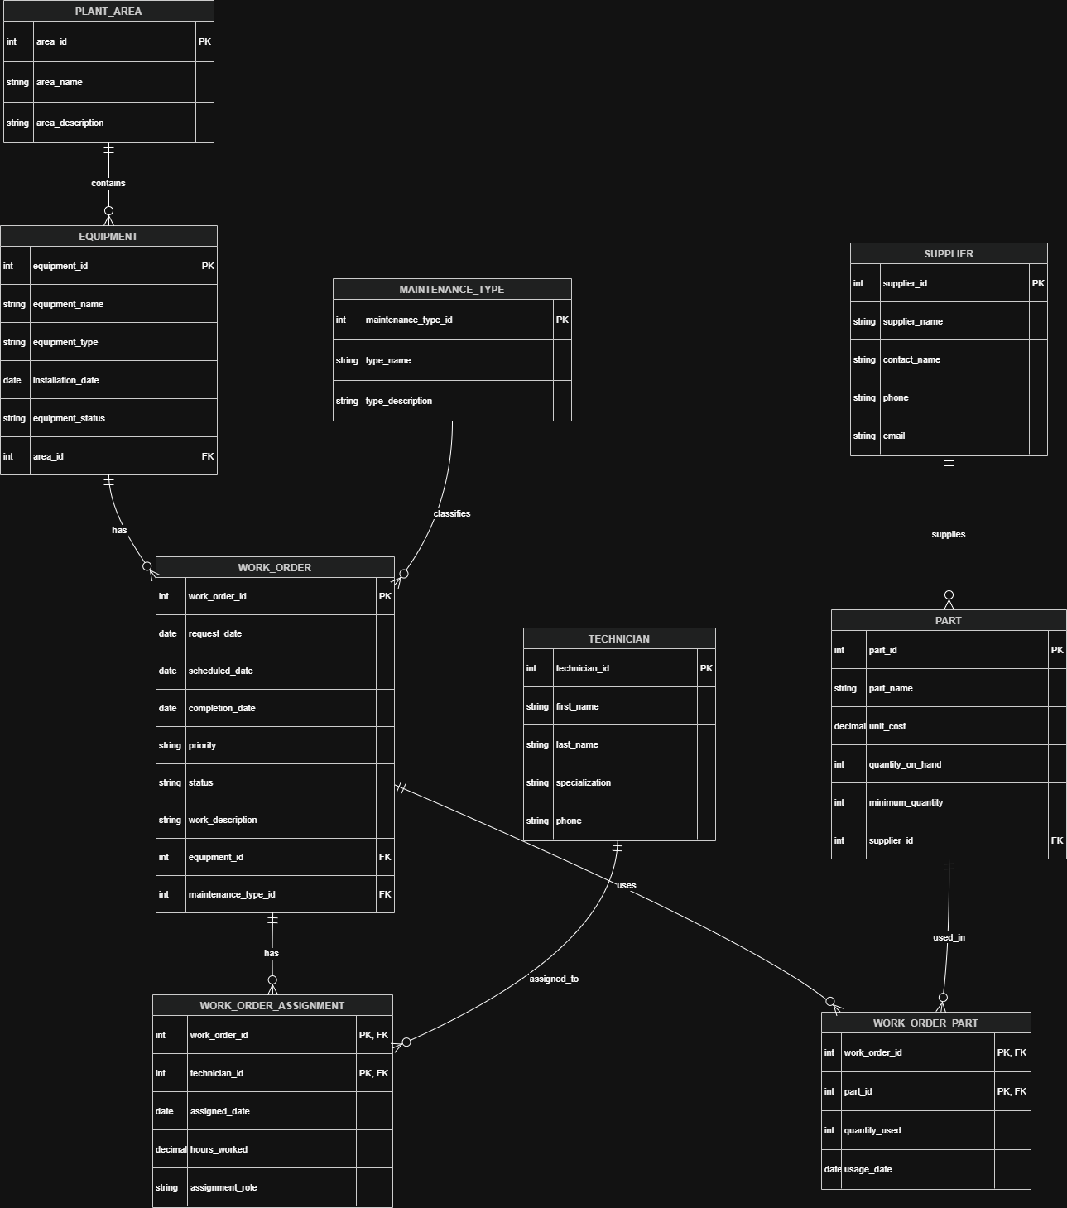

6. Normalization (Up to 3NF)

First Normal Form (1NF)
- All attributes contain atomic values
- No repeating groups
- Each table has a primary key

Second Normal Form (2NF)
- All tables are in 1NF
- No partial dependencies exist
- Composite key tables depend on full key

Third Normal Form (3NF)
- All tables are in 2NF
- No transitive dependencies
- Non-key attributes depend only on primary key
Example:
- Supplier data is stored in a separate table
- PART only stores supplier_id
- This avoids redundancy

7. Functional Dependency Diagram
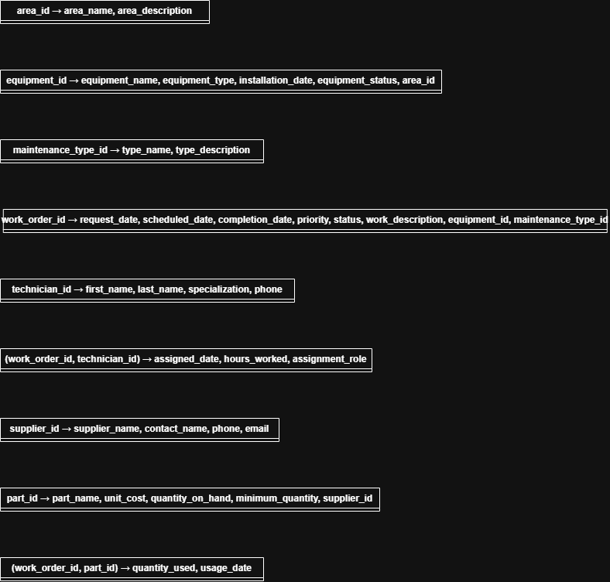

8. SQL Implementation

8.1 CREATE TABLE Statements
“CREATE TABLE PLANT_AREA (
area_id INT PRIMARY KEY,
area_name VARCHAR(50) NOT NULL,
area_description VARCHAR(100)
);

CREATE TABLE MAINTENANCE_TYPE (
maintenance_type_id INT PRIMARY KEY,
type_name VARCHAR(50) NOT NULL,
type_description VARCHAR(100)
);”
“CREATE TABLE TECHNICIAN (
technician_id INT PRIMARY KEY,
first_name VARCHAR(30) NOT NULL,
last_name VARCHAR(30) NOT NULL,
specialization VARCHAR(50),
phone VARCHAR(15)
);

CREATE TABLE SUPPLIER (
supplier_id INT PRIMARY KEY,
supplier_name VARCHAR(50) NOT NULL,
contact_name VARCHAR(50),
phone VARCHAR(15),
email VARCHAR(50)
);
“
“CREATE TABLE EQUIPMENT (
equipment_id INT PRIMARY KEY,
equipment_name VARCHAR(50) NOT NULL,
equipment_type VARCHAR(50),
installation_date DATE,
equipment_status VARCHAR(20),
area_id INT,
FOREIGN KEY (area_id) REFERENCES PLANT_AREA(area_id)
);

CREATE TABLE PART (
part_id INT PRIMARY KEY,
part_name VARCHAR(50) NOT NULL,
unit_cost DECIMAL(8,2),
quantity_on_hand INT,
minimum_quantity INT,
supplier_id INT,
FOREIGN KEY (supplier_id) REFERENCES SUPPLIER(supplier_id)
);
“
“CREATE TABLE WORK_ORDER (
work_order_id INT PRIMARY KEY,
request_date DATE,
scheduled_date DATE,
completion_date DATE,
priority VARCHAR(20),
status VARCHAR(20),
work_description VARCHAR(100),
equipment_id INT,
maintenance_type_id INT,
FOREIGN KEY (equipment_id) REFERENCES EQUIPMENT(equipment_id),
FOREIGN KEY (maintenance_type_id) REFERENCES MAINTENANCE_TYPE(maintenance_type_id)
);

CREATE TABLE WORK_ORDER_ASSIGNMENT (
work_order_id INT,
technician_id INT,
assigned_date DATE,
hours_worked DECIMAL(5,2),
assignment_role VARCHAR(50),
PRIMARY KEY (work_order_id, technician_id),
FOREIGN KEY (work_order_id) REFERENCES WORK_ORDER(work_order_id),
FOREIGN KEY (technician_id) REFERENCES TECHNICIAN(technician_id)
);
“
“CREATE TABLE WORK_ORDER_PART (
work_order_id INT,
part_id INT,
quantity_used INT,
usage_date DATE,
PRIMARY KEY (work_order_id, part_id),
FOREIGN KEY (work_order_id) REFERENCES WORK_ORDER(work_order_id),
FOREIGN KEY (part_id) REFERENCES PART(part_id)
);”
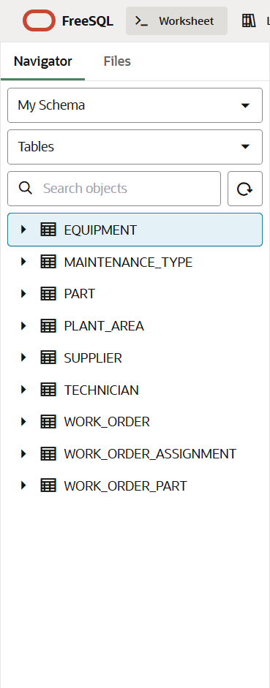

8.2 INSERT Statements
“-- PLANT_AREA
INSERT INTO PLANT_AREA VALUES (1, 'Area A', 'Assembly Section');
INSERT INTO PLANT_AREA VALUES (2, 'Area B', 'Packaging Section');

-- MAINTENANCE_TYPE
INSERT INTO MAINTENANCE_TYPE VALUES (1, 'Preventive', 'Routine check');
INSERT INTO MAINTENANCE_TYPE VALUES (2, 'Corrective', 'Fix issue');

-- TECHNICIAN
INSERT INTO TECHNICIAN VALUES (1, 'Ali', 'Hassan', 'Electrical', '0501234567');
INSERT INTO TECHNICIAN VALUES (2, 'Omar', 'Saleh', 'Mechanical', '0509876543');

-- SUPPLIER
INSERT INTO SUPPLIER VALUES (1, 'ABC Supplies', 'Khalid', '0511111111', 'abc@mail.com');

-- EQUIPMENT (fixed date)
INSERT INTO EQUIPMENT
VALUES (1, 'Pump A', 'Pump', TO_DATE('2020-01-01','YYYY-MM-DD'), 'Active', 1);

-- PART
INSERT INTO PART VALUES (1, 'Valve', 50.00, 20, 5, 1);”
“-- WORK_ORDER (fixed dates)
INSERT INTO WORK_ORDER
VALUES (
1,
TO_DATE('2024-01-01','YYYY-MM-DD'),
TO_DATE('2024-01-02','YYYY-MM-DD'),
NULL,
'High',
'Open',
'Fix leak',
1,
2
);

-- WORK_ORDER_ASSIGNMENT (fixed date)
INSERT INTO WORK_ORDER_ASSIGNMENT
VALUES (1, 1, TO_DATE('2024-01-02','YYYY-MM-DD'), 3.5, 'Lead');

-- WORK_ORDER_PART (fixed date)
INSERT INTO WORK_ORDER_PART
VALUES (1, 1, 2, TO_DATE('2024-01-02','YYYY-MM-DD'));”

9. SQL Queries and Results

Query 1 — Open Work Orders
“SELECT wo.work_order_id, wo.status, e.equipment_name, pa.area_name
FROM WORK_ORDER wo
JOIN EQUIPMENT e ON wo.equipment_id = e.equipment_id
JOIN PLANT_AREA pa ON e.area_id = pa.area_id
WHERE wo.status = 'Open';”

Query 2 — Work Orders by Maintenance Type
“SELECT mt.type_name, COUNT(*) AS total
FROM MAINTENANCE_TYPE mt
JOIN WORK_ORDER wo ON mt.maintenance_type_id = wo.maintenance_type_id
GROUP BY mt.type_name;”

Query 3 — Total Parts Cost per Work Order
“SELECT wo.work_order_id,
SUM(wop.quantity_used * p.unit_cost) AS total_cost
FROM WORK_ORDER wo
JOIN WORK_ORDER_PART wop ON wo.work_order_id = wop.work_order_id
JOIN PART p ON wop.part_id = p.part_id
GROUP BY wo.work_order_id;”

Query 4 — Equipment with Most Work Orders
“SELECT e.equipment_name, COUNT(*) AS total
FROM EQUIPMENT e
JOIN WORK_ORDER wo ON e.equipment_id = wo.equipment_id
GROUP BY e.equipment_name
ORDER BY total DESC;”

Query 5 — Parts Below Minimum Quantity
“SELECT part_name, quantity_on_hand, minimum_quantity
FROM PART
WHERE quantity_on_hand < minimum_quantity;”

10. Conclusion
This project successfully designed and implemented a database for a plant maintenance system. The system organizes maintenance data efficiently and supports operational decision-making.
The database was normalized up to 3NF to eliminate redundancy and ensure data integrity. The ERD clearly represents relationships between entities, and SQL implementation demonstrates how the database can be used in practice.
Overall, the system improves maintenance tracking, resource allocation, and inventory management within a plant environment.

